**Questions and Answers:**

1. Run nslookup to obtain the IP address of the web server for the Indian Institute of Technology in Bombay, India: www.iitb.ac.in. What is the IP address of www.iitb.ac.in.

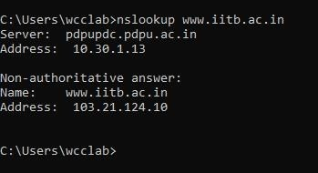

1. What is the IP address of the DNS server that provided the answer to your nslookup command in question 1 above?

3.

ANS: **103.21.124.10**

1. Did the answer to your nslookup command in question 1 above come from an authoritative or non-authoritative server?

ANS: **Non-Authoritative Server**

1. Use the nslookup command to determine the name of the authoritative name server for the iit.ac.in domain. What is that name? (If there are more than one authoritative servers, what is the name of the first authoritative server returned by nslookup)? If you had to find the IP address of that authoritative name server, how would you do so?

ANS:

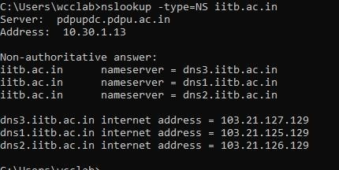

1. Locate the first DNS query message resolving the name gaia.cs.umass.edu. What is the packet number in the trace for the DNS query message? Is this query message sent over UDP or TCP?

ANS: **28028** is the packet number in trace of DNS query message and it is sent over UDP protocol.

1. Now locate the corresponding DNS response to the initial DNS query. What is the packet number in the trace for the DNS response message? Is this response message received via UDP or TCP?

ANS**: 28029** is the packet number in the trace for DNS response message and it is received via UDP protocol.

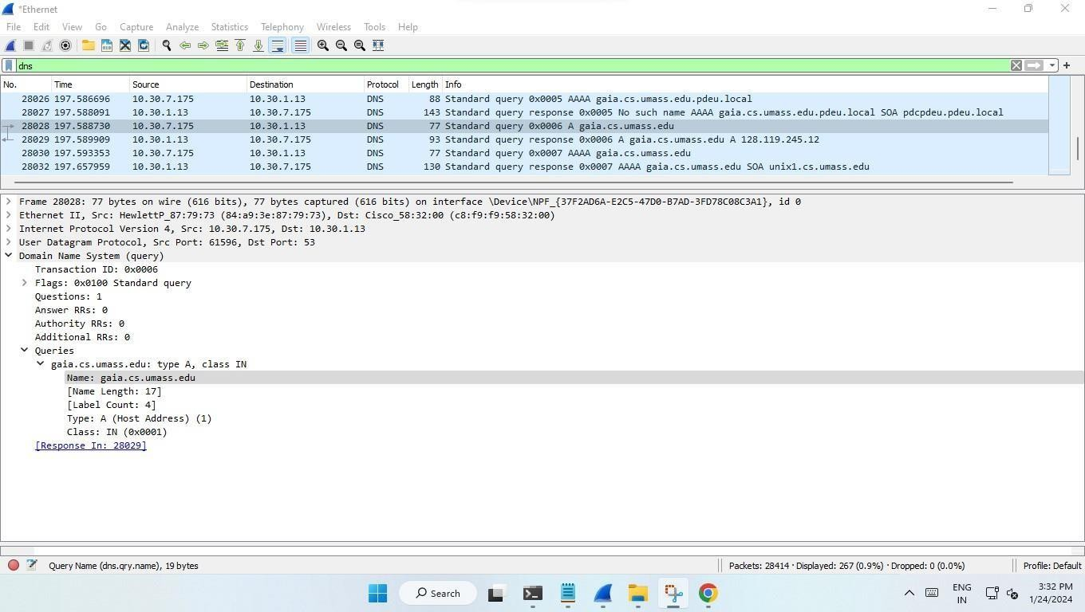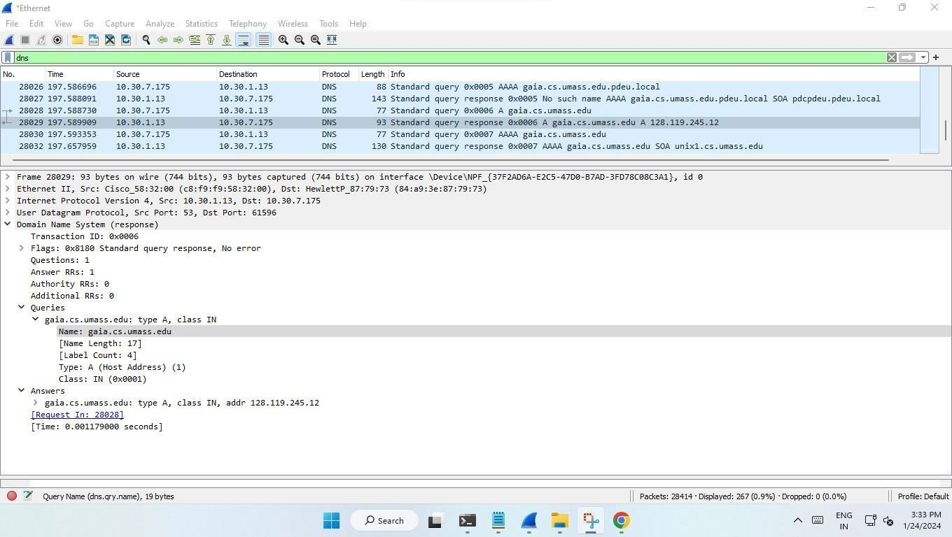

1. What is the destination port for the DNS query message? What is the source port of the DNS response message?

ANS: To what IP address is the DNS query message sent?

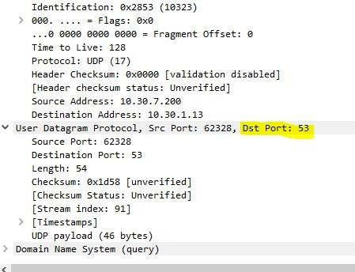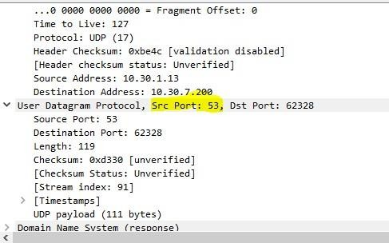

ANS: **10.30.1.13**

1. Examine the DNS query message. How many “questions” does this DNS message contain?

How many “answers” answers does it contain?

1. 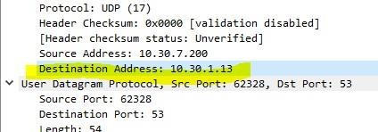

ANS: It contains 1 question and 0 answers.

1. Examine the DNS response message to the initial query message. How many “questions” does this DNS message contain? How many “answers” answers does it contain?

ANS: It contains 1 question and 1 answer.

1. The web page for the base file [http://gaia.cs.umass.edu/kurose_ross/ refe](http://gaia.cs.umass.edu/kurose_ross/)rences the image object [http://gaia.cs.umass.edu/kurose_ross/header_graphic_book_8E_2.jpg ,](http://gaia.cs.umass.edu/kurose_ross/header_graphic_book_8E_2.jpg) which, like the base webpage, is on gaia.cs.umass.edu. What is the packet number in the trace for the initial HTTP GET request for the base file [http://gaia.cs.umass.edu/kurose_ross/? Wha](http://gaia.cs.umass.edu/kurose_ross/)t is the packet number in the trace of the DNS query made to resolve gaia.cs.umass.edu so that this initial HTTP request can be sent to the gaia.cs.umass.edu IP address?

What is the packet number in the trace of the received DNS response? What is the packet number in the trace for the HTTP GET request for the image object [http://gaia.cs.umass.edu/kurose_ross/header_graphic_book_8E2.jpg? Wha](http://gaia.cs.umass.edu/kurose_ross/header_graphic_book_8E2.jpg)t is the packet number in the DNS query made to resolve gaia.cs.umass.edu so that this second HTTP request can be sent to the gaia.cs.umass.edu IP address? Discuss how DNS caching affects the answer to this last question.

ANS: The packet number in the trace for the initial HTTP GET request is 1001.

The packet number in the trace of DNS query of initial HTTP request is 7. The packet number in the trace of received DNS response is 10.

The packet number in the trace for the HTTP GET request for the image object [http://gaia.cs.umass.edu/kurose_ross/header_graphic_book_8E2.jpg is 1](http://gaia.cs.umass.edu/kurose_ross/header_graphic_book_8E2.jpg)33.

The packet number in the DNS query made to resolve gaia.cs.umass.edu is 6.

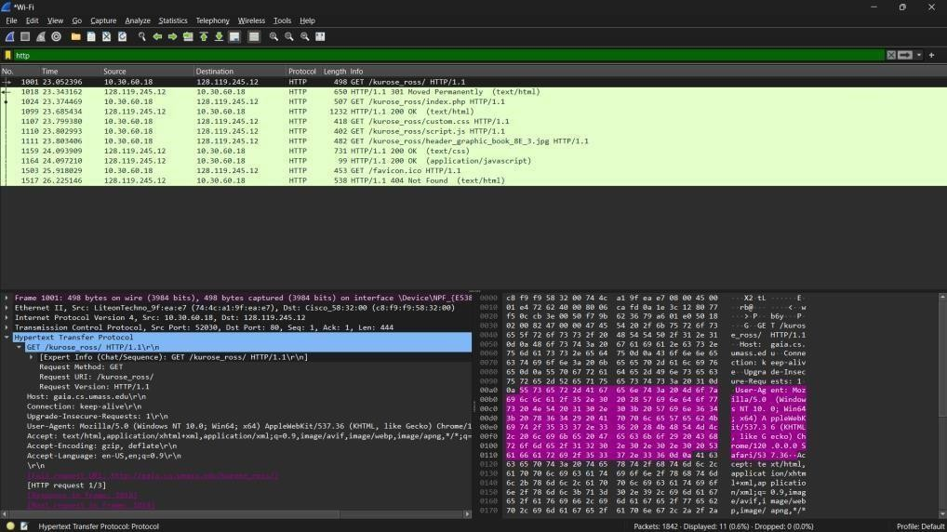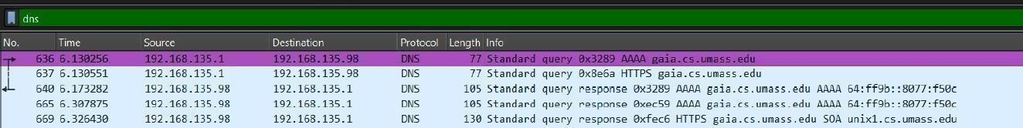

1. What is the destination port for the DNS query message? What is the source port of the DNS response message?

ANS: The destination port for DNS query message is 53 and the source port for the DNS response message is 53.

1. To what IP address is the DNS query message sent? Is this the IP address of your default local DNS server?

ANS: The DNS query message is sent to IP Address 192.168.1.1 and it is default local DNS server.

1. Examine the DNS query message. What “Type” of DNS query is it? Does the query message contain any “answers”?

ANS: The DNS query is TYPE A for IPv4 address and Type AAAA for IPv6 address.

NO, the query message does not contain any answers.

1. Examine the DNS response message to the query message. How many “questions” does this DNS response message contain? How many “answers”?

ANS: DNS response message contains 1 Question and 1 Answer.

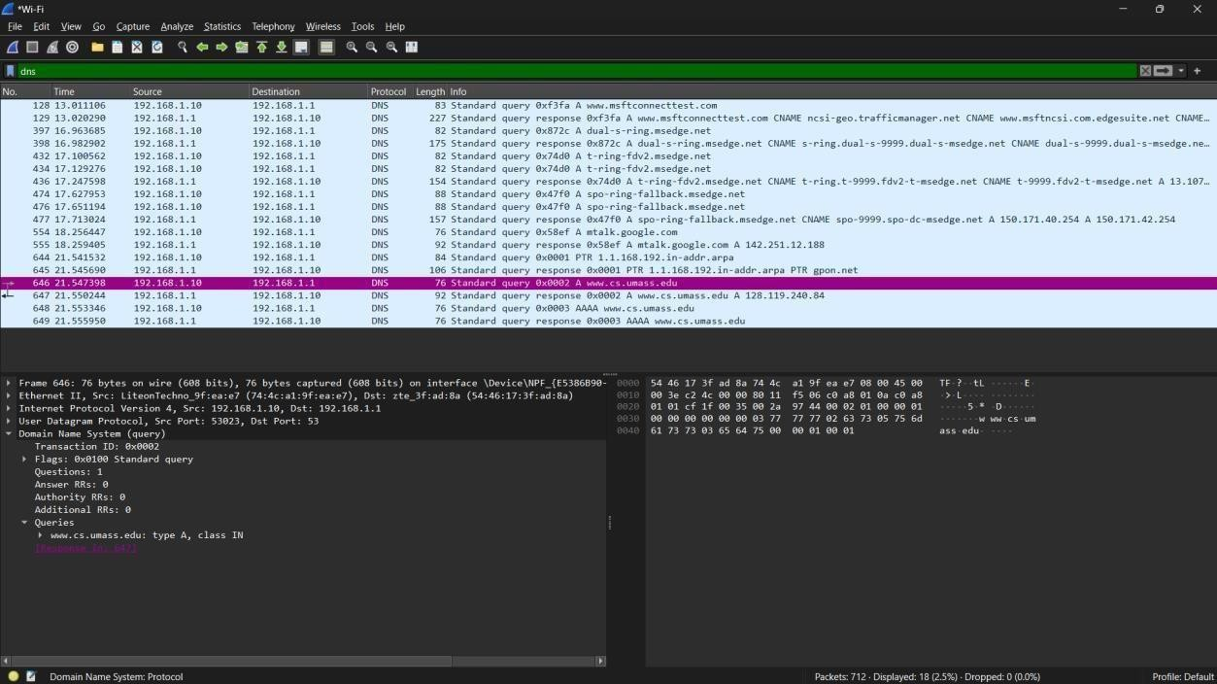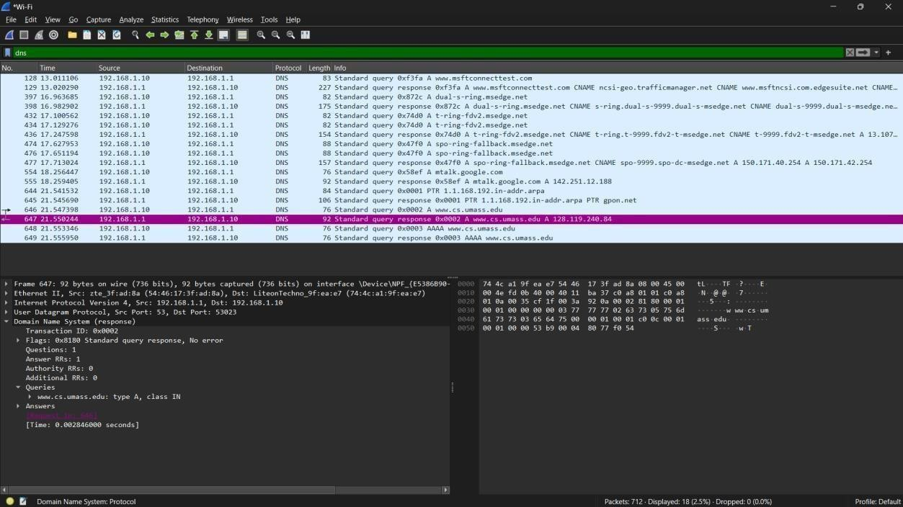

1. To what IP address is the DNS query message sent? Is this the IP address of your default local DNS server?

ANS: The DNS query message is sent to IP Address 192.168.1.1 and it is default local DNS server.

1. Examine the DNS query message. How many questions does the query have? Does the query message contain any “answers”?

ANS: The DNS query message contains 1 question and it does not contain any answers.

1. Examine the DNS response message. How many answers does the response have? What information is contained in the answers? How many additional resource records are returned? What additional information is included in these additional resource records?

ANS: The DNS response contains only 1 answer.

The answer contains the information like Name, Type, Class, time to live, length and IP address.

No additional resource records are returned and no additional information is included in these Additional resource records.



